**Name: Kunal Thakur**

**Class: TY-CSF-1**

**Rollno: 2213225**

**Batch: B**

**Assignment No.: 3**

**Aim:** Data Manipulation Commands for updating and retrieving of data from Tables and Transaction Control statements

1. Insert 5 values in the Table for Manufacturing industry / Hospital/ Company.
2. Update the values from the tables Manufacturing industry / Hospital/ Company.
3. Delete minimum 2 values from Manufacturing industry / Hospital/ Company table

**Software Required:** MySQL

**Theory:** Data Manipulation Language (DML) commands in a Database Management System (DBMS) are a set of commands used to manipulate or interact with the data stored in the database. DML commands are primarily focused on performing operations such as retrieving, inserting, updating, and deleting data within the database.

DML commands in DBMS include:

**1. SELECT**: The SELECT command is used to retrieve data from one or more tables in the database. It allows you to specify the columns or attributes you want to retrieve, as well as conditions to filter the data based on certain criteria. SELECT is primarily used for querying and retrieving data.

**2. INSERT**: The INSERT command is used to add new records or rows of data into a table in the database. It allows you to specify the values for each column or attribute in the table, and the DBMS will insert the new data accordingly.

**Syntax:** INSERT INTO *table_name* (*column1*, *column2*, *column3*, ...)

VALUES (*value1*, *value2*, *value3*, ...);

**3. UPDATE**: The UPDATE command is used to modify existing records or rows in a table. It allows you to specify the changes or updates you want to make to one or more columns or attributes in the table. You can also use conditions to determine which records should be updated.

**Syntax:**

UPDATE *table_name* SET *column1* = *value1*, *column2* = *value2*, ...

WHERE *condition*;

**4. DELETE:** The DELETE command is used to remove records or rows from a table in the database. It allows you to specify certain conditions to determine which records should be deleted. When executed, the DBMS will remove the specified records from the table.

**Syntax:**

DELETE FROM *table_name* WHERE *condition*;

**SQL commands:**

**A.**

CREATE TABLE Hospital (Name varchar(255), Address varchar(255), speciality varchar(255), capacity int);

INSERT INTO Hospital(Hosp_Name, Address, Speciality, Capacity)

VALUES('Nova', 'Pune', 'IVF',30);

INSERT INTO Hospital(Hosp_Name, Address, Speciality, Capacity)

VALUES('Nova', 'Pune', 'IVF',30);

INSERT INTO Hospital VALUES(‘Motherhood', 'Pune', 'Mom n child',60);

:

:

:

:

INSERT INTO Hospital VALUES(‘Sahyadri', 'Pune', 'Multispeciality',100);

**B.**

UPDATE Hospital SET Capacity = ‘45’ where Hosp_Name = ‘Nova’;

**C.**

DELETE FROM Hospital WHERE Capacity = 100;

**Output:**

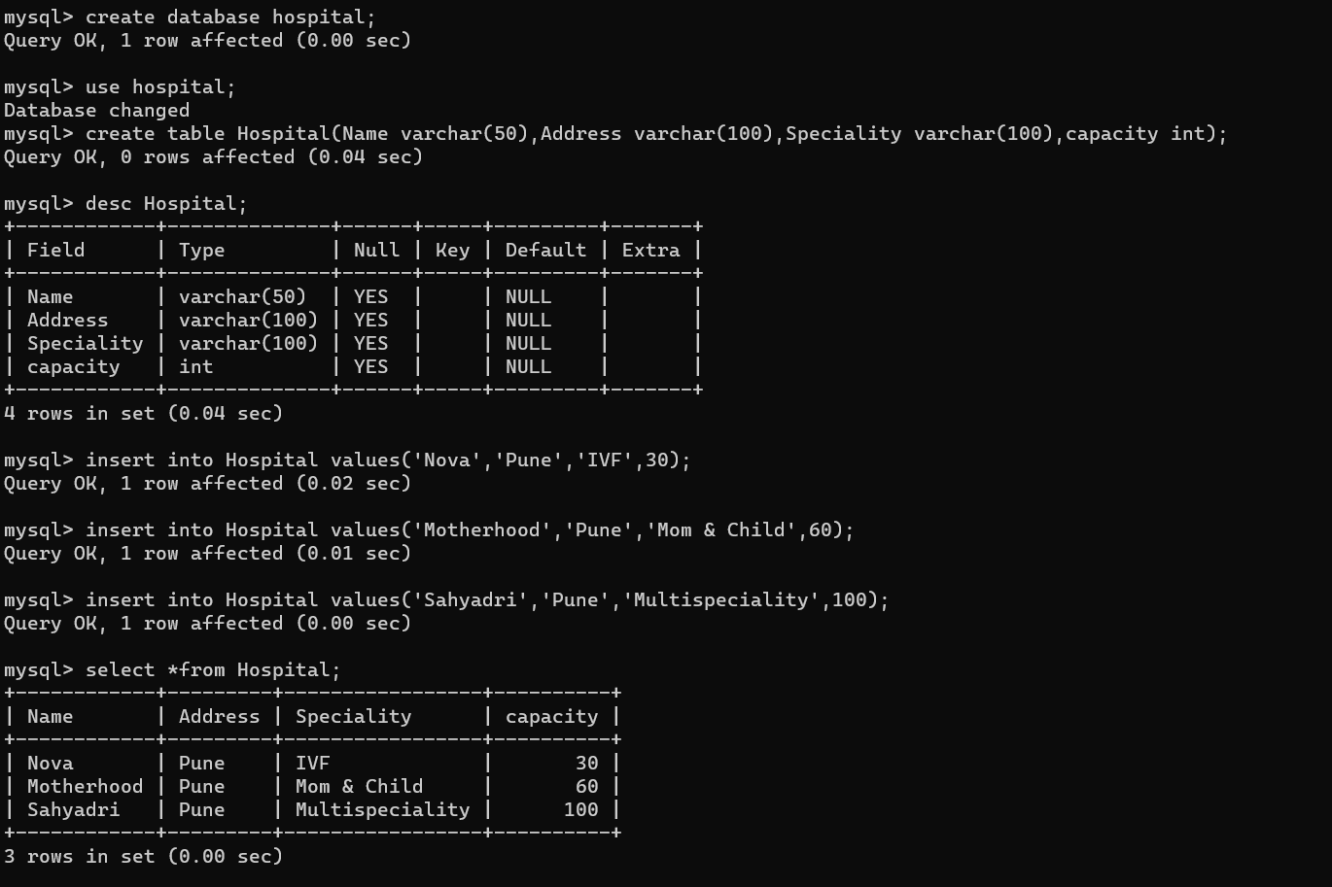

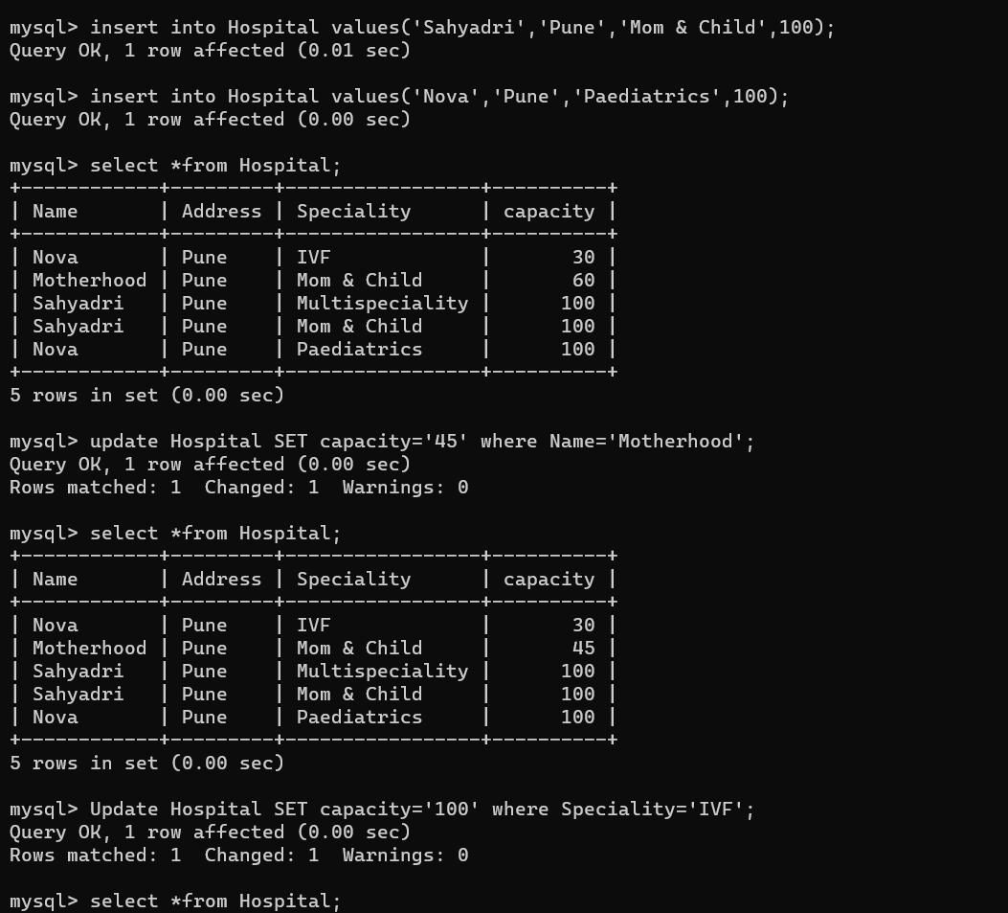

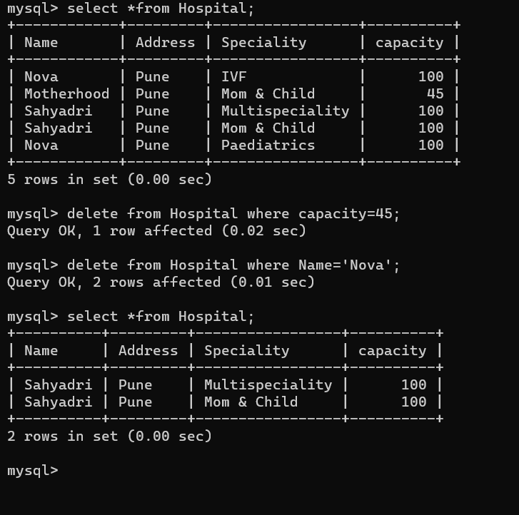

**Conclusion:** These DML commands provide the necessary functionality to manipulate and manage the data within a DBMS. They allow users to interact with the database by retrieving, inserting, updating, and deleting data according to their requirements.

**FAQs:**

1. What is the purpose of the WHERE clause in SQL DML commands?

Ans : The WHERE clause is used to filter records. It is used to extract only those records that fulfill a specified condition.

Syntax:

SELECT column1,column2 FROM table_name WHERE column_name operator value;

II. How can I update multiple columns in a table using UPDATE?

III. Can I insert data into multiple tables at once?

IV. What is the difference between the INSERT and UPDATE commands?

**Additional problem statements:**

I. Design an SQL command to insert a new product record into the "Products" table of the online store database, including details such as product name, price, quantity available, and category.

II. Create a set of DML commands to update the "Employee" table in the HR database, modifying the salary of an employee based on their performance rating and position.

III. Develop an SQL script to delete all inactive user accounts from the "Users" table of the social networking database, where the last login date is older than six months.

IV. Design a series of DML commands to insert a new patient's medical record into the "Patients" table of the hospital database, capturing information like patient ID, name, date of birth, admission date, and medical condition.

V. Create an SQL command to update the "Inventory" table in the retail store database, increasing the quantity of a specific product that has been restocked.